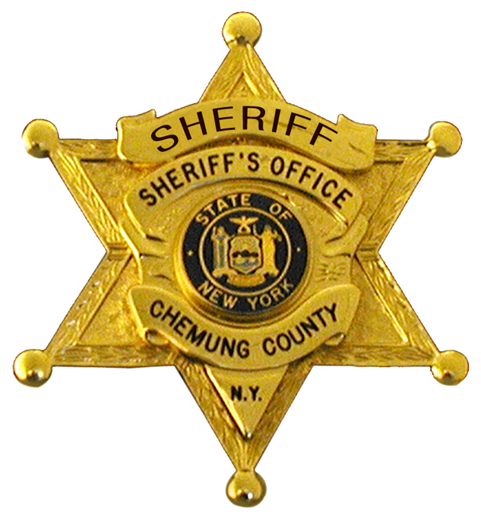
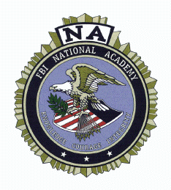
SHERIFF OF CHEMUNG COUNTY
203 William Street
P.O. Box 588
Elmira, New York 14902-0588
Administrative Office: (607) 737-2987 Fax: (607) 737-2930

CHRISTOPHER J. MOSS WILLIAM A. SCHROM
Sheriff Undersheriff

NEWS RELEASE

August 2, 2016

The Chemung County Sheriff’s Office will be holding a press conference Wednesday, August 3rd at 9:45 a.m. The Sheriff’s Office will be introducing a new initiative titled Operation H.O.P.E. (Heroin & Opioid Prevention Effort) in Chemung County. The initiative is a multi-faceted approach to assist with addressing the opiate epidemic throughout the region. The press conference will be held on the 2nd Floor of the Hazlett Building at 203 Lake Street, Elmira.

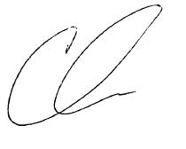
Christopher Moss
Chemung County Sheriff

CJM/mab

